Chimera user manual
Board connection
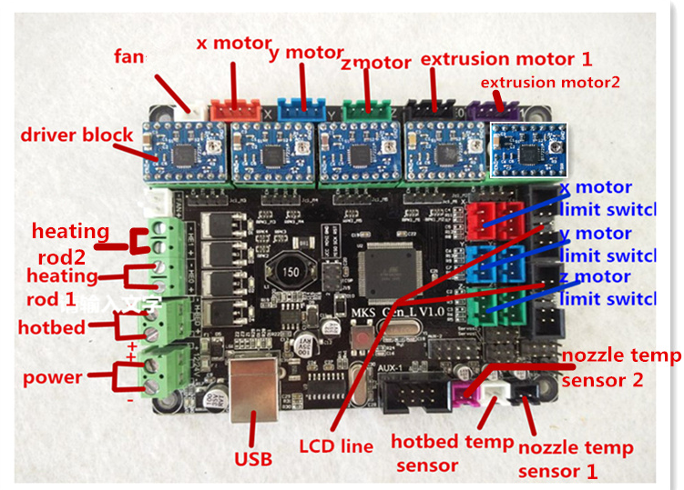
Note: extrder 1 is the one close x switch ,extruder 2 is away from the x switch
Repetier parameter setting
Printer setting
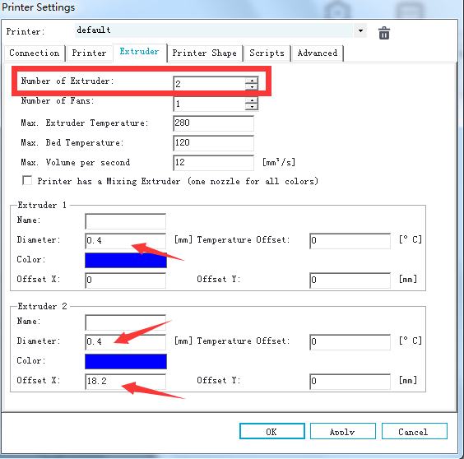
Then open sclie software configuration
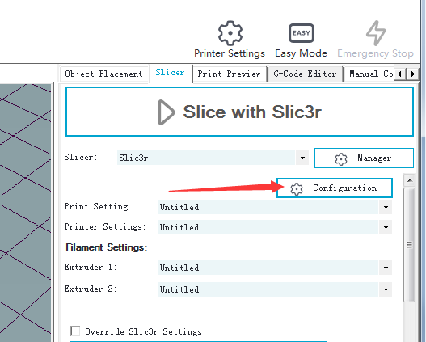
You can choose use which extruder
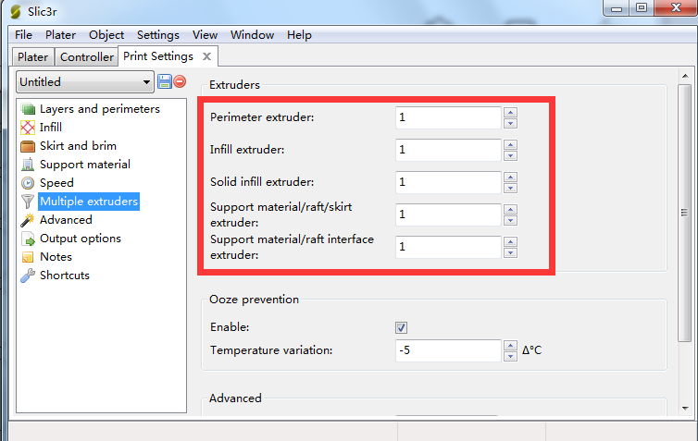

For example:use extruder2 while printing support
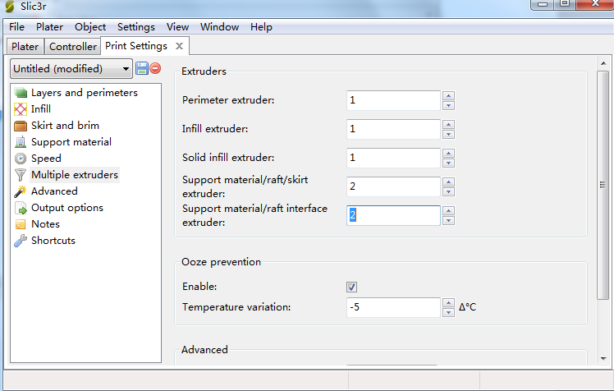
Then you slice your model and start print.

Cyclops user manual
Board connection
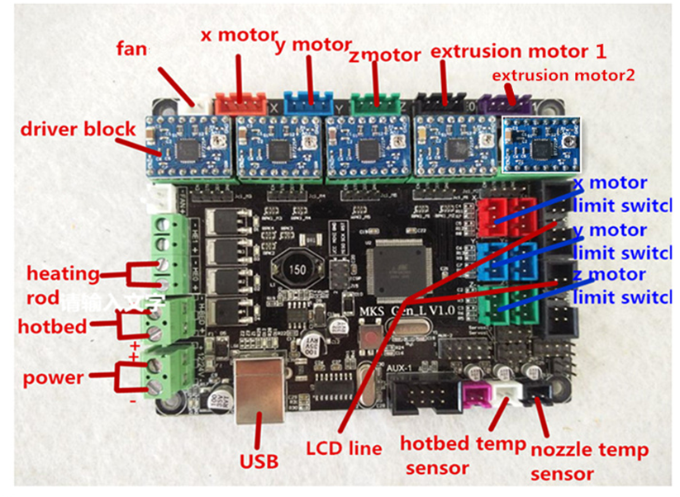
Repetier parameter setting
Printer setting
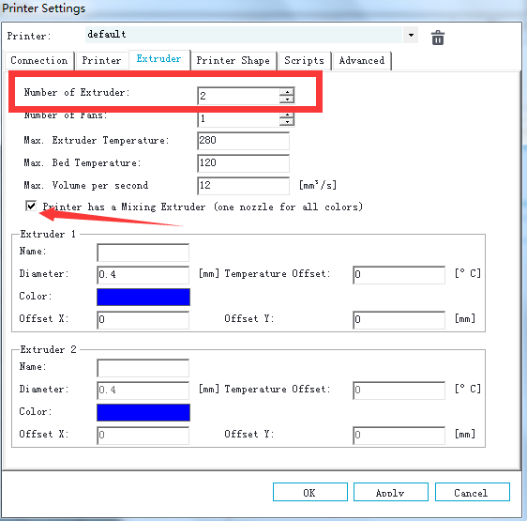
Use Cyclops you can print a mix colour or use different extruder in different height
Mix colour:
Use code to control
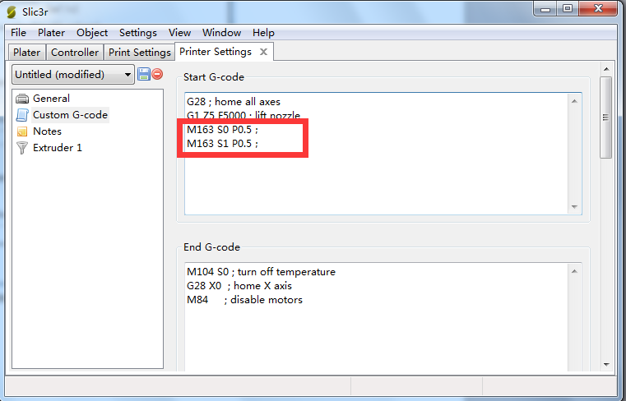
M163 S0 P0.5；//extruder1 Provide 50% extrusion
M163 S1 P0.5；//extruder2 provide 50% extrusion
You also can use different proportions,for example:M163 S0 P0.3；M163 S1 P0.7；
You also can use one extruder ,for example:M163 S0 P1.0;// use extruder1

use different extruder in different height
For example use extruder1 in bottom ,mix colour in center ,use extruder2 in top.
Firse we slice a model and get a gcode file.then edit gcode.
Bottom:
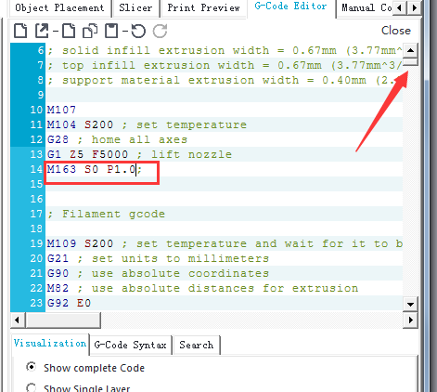

Center:
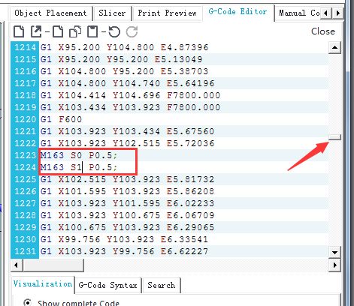

Top:
